**Challenge o**

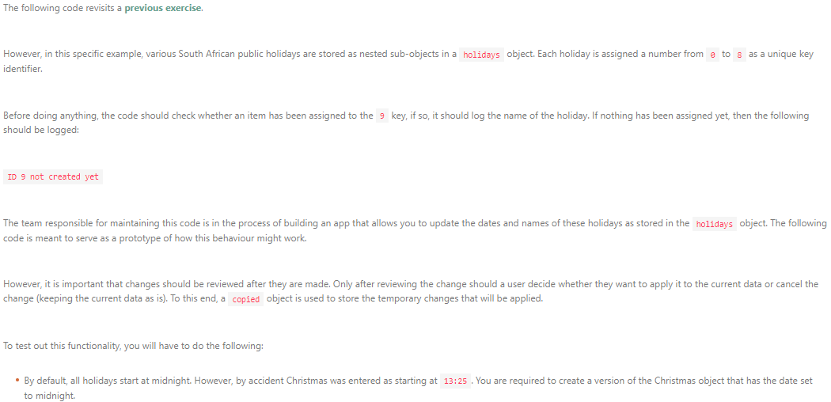

const currentYear = new Date().getFullYear()

const holidays = {

0: {

id: 0,

name: 'Day of Reconciliation',

date: `16 December ${currentYear}`,

},

1: {

id: 1,

name: 'Workers Day',

date: new Date(`1 April ${currentYear}`),

},

2: {

id: 2,

name: 'Day of Goodwill',

date: new Date(`26 December ${currentYear}`),

},

3: {

id: 3,

name: 'New Year Day',

date: new Date(`1 January ${currentYear}`),

},

4: {

id: 4,

name: 'Womens Day',

date: new Date(`9 August ${currentYear}`),

},

5: {

id: 5,

name: 'Heritage Day',

date: new Date(`24 September ${currentYear}`),

},

6: {

id: 6,

name: 'Christmas Day',

date: new Date(`25 December ${currentYear} 13:25`),

},

7: {

id: 7,

name: 'Youth Day',

date: new Date(`16 June ${currentYear}`),

},

8: {

id: 8,

name: 'Human Rights Day',

date: new Date(`21 March ${currentYear}`)

},

}

const christmas = 6

const futureId = 9

// Do not change code above this comment

console.log(holidays.futureId.name || 'ID {futureId} not created yet')

copied = holidays.christmas

copied = { name: 'X-mas Day' }

correctDate = copied.date

correctDate.hours = 0

correctDate.minutes = 0

isEarlier = copied.date < holidays[6].date

console.log('New date is earlier:', isEarlier)

if (isEarlier) copied.date = correctDate

console.log('ID change:', holidays[christmas].id != copied.id || copied.id)

console.log('Name change:', holidays[christmas].name != copied.name || copied.name)

console.log('Date change:', holidays[christmas].date != copied.date || copied.date)

const firstHolidayTimestamp = Math.min(

holidays[0].date.getTime,

holidays[1].date.getTime,

holidays[2].date.getTime,

holidays[3].date.getTime,

holidays[4].date.getTime,

holidays[5].date.getTime,

holidays[6].date.getTime,

holidays[7].date.getTime,

holidays[8].date.getTime,

)

const lastHolidayTimestamp = Math.max(

holidays[0].date.getTime,

holidays[1].date.getTime,

holidays[2].date.getTime,

holidays[3].date.getTime,

holidays[4].date.getTime,

holidays[5].date.getTime,

holidays[6].date.getTime,

holidays[7].date.getTime,

holidays[8].date.getTime,

)

const firstDay = firstHolidayTimestamp.getDate

const firstMonth = firstHolidayTimestamp.getMonth

const lastDay = lastHolidayTimestamp.getDate

const lastMonth = lastHolidayTimestamp.getMonth

console.log('{firstDay}/{firstMonth}/{currentYear}')

console.log('{lastDay}/{lastMonth}/{currentYear}')

const randomHoliday = holidays[Math.random]

console.log(randomHoliday.date)